

**NATIONAL UNIVERSITY OF TECHNOLOGY (NUTECH)**

**DEPARTMENT OF COMPUTER SCIENCE**

**REPORT-1A**



**INTERNSHIP**

**REPORT**

**STUDENT NAME: MUHAMMAD ADNAN MALIK**

**REGISTRATION NO: F20605005**

**DEGREE PROGRAM: BS COMPUTER SCIENCE**

**INTERNSHIP COMPANY: PAKISTAN INTERNATIONAL AIRLINES (PIA)**

**POSITION AND DATA: IT DEPARTMENT INTERNEE**

**ABSTRACT**

During the summer break, I, Adnan Malik, a student in the BS Computer Science program at NUTECH University, embarked on a seven-week internship at Pakistan International Airlines (PIA). This report aims to provide an in-depth account of my internship experience, detailing the projects undertaken, lessons learned, and the impact of this experience on my academic and career goals.

**TABLE OF CONTENTS**

**1. BACKGROUND/OVERVIEW OF COMPANY**

* Introduction to Pakistan International Airlines (PIA)
* Overview of PIA's IT Department

**2. SUMMARY OF DUTIES**

* 2.1 Description of Assigned Responsibilities
* 2.2 Key Projects and Tasks Undertaken
* 2.3 Collaborative Initiatives and Team Contributions

**3. WORKING EXPERIENCES**

* 3.1 Day-to-Day Experiences and Learning
* 3.2 Notable Challenges and Problem-Solving
* 3.3 Professional Development and Skill Enhancement

**4. APPLICABILITY TO DEGREE**

* 4.1 Integration of Internship Experience with Academic Studies

**5. AFFECT ON CAREER GOALS**

* 5.1 Influence of Internship on Future Career Aspirations

**6. CONCLUSION**

* 6.1 Overall Assessment of Internship Experience

**7. SUMMARY**

* A brief recap of key takeaways

**8. APPENDIX**

* Appendix 1: Supporting links of Project Submissions

**1. BACKGROUND/OVERVIEW OF COMPANY**

**1.1 Introduction to Pakistan International Airlines (PIA)**

Pakistan International Airlines (PIA) is the flag carrier airline of Pakistan, with a rich history dating back to 1954. Renowned for its extensive global network, commitment to safety, and exceptional passenger services, PIA has played a pivotal role in connecting Pakistan to the world.

**1.2 Overview of PIA's IT Department**

PIA's IT department is a critical component of the organization, responsible for ensuring the seamless operation of various technological aspects, including network management, software development, data analytics, and cybersecurity.

**2. SUMMARY OF DUTIES**

**2.1 Description of Assigned Responsibilities**

During my internship at PIA's IT department, I was entrusted with a range of responsibilities, which included the following key tasks:

* Developed straightforward and contemporary webpage layouts using fundamental HTML and CSS.
* Creating a single-page form design with JavaScript.
* Designing an interactive Bubble Game with JavaScript.
* Developing a software solution for CRUD (Create, Read, Update, Delete) operations using PHP.
* Gaining proficiency in jQuery and Bootstrap through dedicated learning endeavors.

**2.2 Key Projects and Tasks Undertaken**

Over the course of seven weeks, I had the privilege of contributing to several noteworthy projects:

* **Project 1: Crafting Webpage Layouts (HTML/CSS)**
* **Description:** I was tasked with creating modern and user-friendly webpage layouts using fundamental HTML and CSS.
* **Achievements:** Successfully designed straightforward and contemporary web layouts, integrating responsive design principles to enhance user experience.

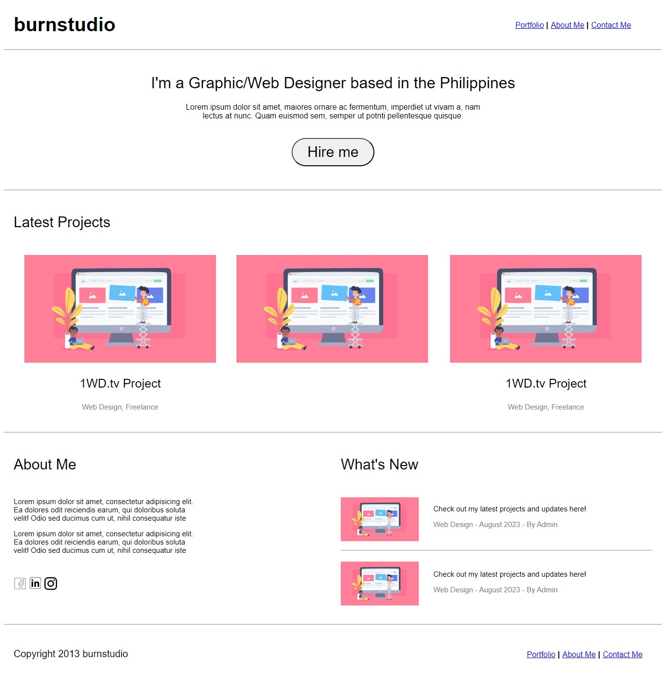

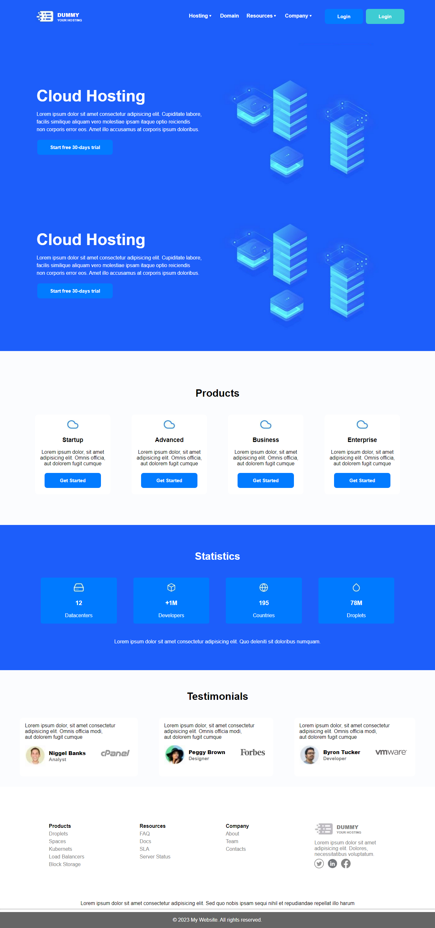

* **Project 2: Single-Page Form Design (JavaScript)**
* **Description:** I developed a dynamic single-page form using JavaScript, improving user interactivity and data collection efficiency.
* **Achievements:** Designed an intuitive form that streamlined data input and validation processes.

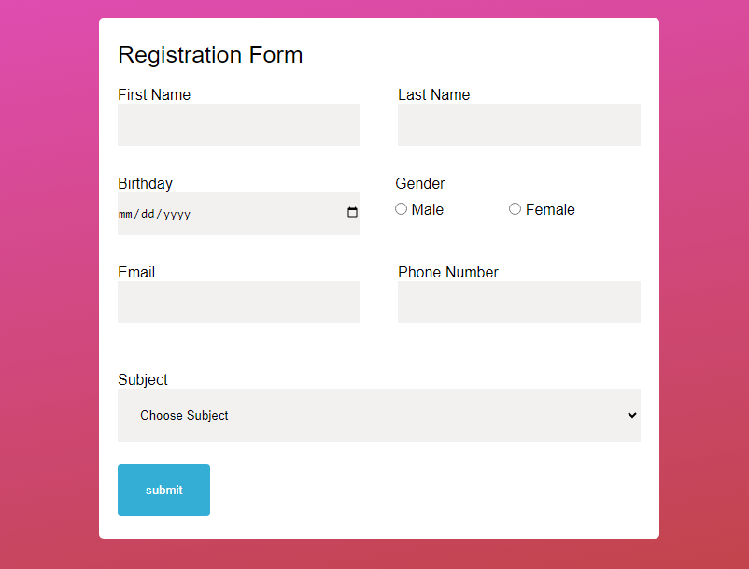

* **Project 3: Interactive Bubble Game (JavaScript)**
* **Description:** I created an immersive and interactive Bubble Game using JavaScript, providing an engaging user experience.
* **Achievements:** Developed a captivating game that showcased my programming skills and creativity.



* **Project 4: CRUD Software (PHP)**
* **Description**: I contributed to the development of a software solution for CRUD (Create, Read, Update, Delete) operations using PHP.
* **Achievements:** Gained hands-on experience in database management and application development, adding valuable practical skills to my repertoire.
* **Project 5: Proficiency in jQuery and Bootstrap**
* **Description:** Through dedicated learning efforts, I honed my skills in jQuery and Bootstrap, two vital web development frameworks.
* **Achievements:** Attained proficiency in these frameworks, enhancing my capabilities in web design and development.

**2.3 Collaborative Initiatives and Team Contributions**

My experience at PIA was marked by collaboration with diverse teams. I actively participated in brainstorming sessions, project meetings, and other team activities, contributing to a cohesive work environment and learning from my colleagues.

**3. WORKING EXPERIENCES**

**3.1 Day-to-Day Experiences and Learning**

Each day at PIA brought new challenges and learning opportunities. I had the privilege of working on a variety of tasks, from troubleshooting network issues to coding in various programming languages. The dynamic nature of the work kept me engaged and eager to expand my knowledge.

**3.2 Notable Challenges and Problem-Solving**

While the internship presented several challenges, including tight deadlines and complex coding tasks, I embraced these challenges as opportunities for growth. Through collaboration, research, and determination, I was able to overcome these obstacles and deliver high-quality results.

**3.3 Professional Development and Skill Enhancement**

My time at PIA allowed me to enhance my skills in web development, programming languages, project management, and problem-solving. This practical experience provided a strong foundation for my future career in the field of computer science.

**4. APPLICABILITY TO DEGREE**

The experiences and skills gained during this internship seamlessly align with my academic pursuits at NUTECH University. This integration has enabled me to apply theoretical knowledge to real-world scenarios, enhancing my understanding of the subjects covered in my BS Computer Science program.

**5. AFFECT ON CAREER GOALS**

My internship at PIA has played a pivotal role in shaping my career aspirations. The exposure to industry-standard technologies, collaborative work environments, and hands-on project experiences has reinforced my commitment to pursuing a career in IT management and software development. This internship has provided valuable insights into the dynamic and ever-evolving field of computer science, and I am eager to continue my journey in this direction.

**6. CONCLUSION**

In conclusion, my seven-week internship at PIA's IT department was an invaluable experience that greatly enriched my academic and personal growth. I am deeply grateful for the opportunity and the guidance provided by Sir Javad, which played a crucial role in my development. This internship has not only expanded my technical skillset but also reinforced my passion for computer science.

**7. SUMMARY**

This report has provided a comprehensive overview of my internship at Pakistan International Airlines, highlighting key experiences, projects, and the impact on my academic and career aspirations.

**8. APPENDIX**

* **Appendix 1: Supporting Links of Projects Submissions**
* <https://app.asana.com/0/1205282233922713/1205282233922718>
* <https://app.asana.com/0/1205282233922713/1205341818288508>
* <https://app.asana.com/0/1205282233922713/1205527150826919>

This structured report encapsulates my journey during the internship at PIA, providing a comprehensive view of the experiences, projects, and the impact on my academic and career aspirations.

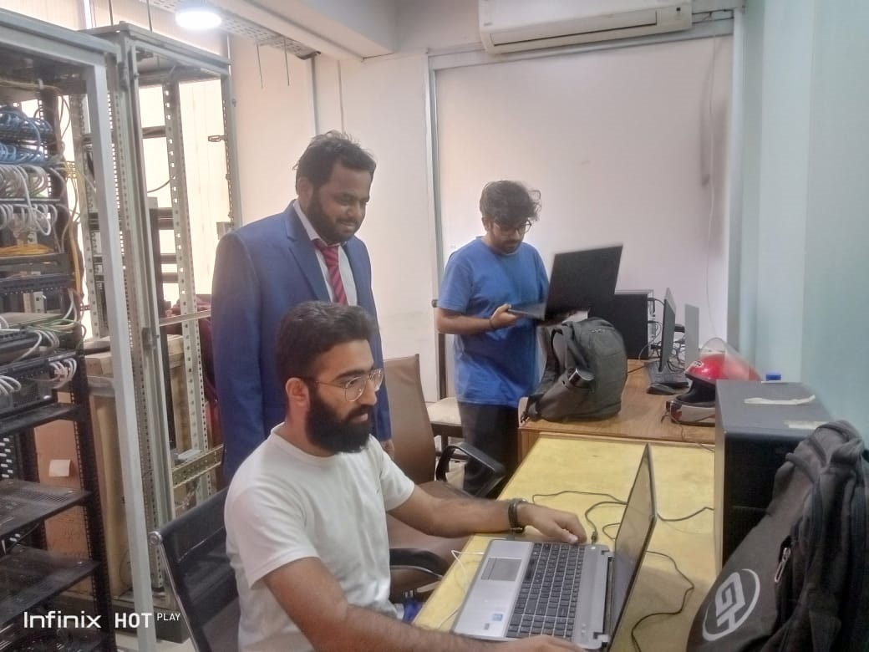

**THANK YOU**